Ⓡ SCI.5.5A Classify matter based on physical properties, including mass, magnetism, physical state solid, liquid, and gas, relative density (sinking and floating), solubility in water (ability to dissolve), and the ability to conduct or insulate thermal energy or electric energy.

Classify MATTER BASED ON PHYSICAL PROPERTIES Including, but not limited to:
- mass – the amount of matter in an object
- magnetism – attracts metal (iron and steel) BUT NOT (aluminum, silver, gold, copper…)
- physical state – solid, liquid, gas
- solid – tightly packed particles with little to no movement in a specific shape
- liquid – particles move some and will take the shape of any container
- gas – fast moving scattered particles
- relative density (sinking and floating) – the more dense something is the more it sinks (Styrofoam floats (less dense that water – EVEN IF IT HAS A HOLE IN IT THE STYROFOAM WILL STILL FLOAT!
- solubility in water – ability to dissolve
- the ability to conduct
- CONDUCTORS are metals – aluminum, copper, steel, iron, gold, silver
or insulate
- INSULATORS are plastic, wood, Styrofoam, rubber
- thermal (heat) or electric energy (will conduct electricity often with a plug or batteries – (a power Source))
Ⓢ SCI.5.5B Identify the boiling and freezing/melting points of water on the Celsius scale.

CHANGES IN WATER CAUSED BY HEATING AND COOLING

• boiling point of water 100°C – water goes from colder to hotter and begins to boil
• freezing point of water 0°C – water begins to freeze (warmer to cooler)
• melting point of water 0°C – ice begins to melt (cooler to warmer)
Ⓢ SCI.3.5C Predict, observe, and record changes in the state of matter caused by heating or cooling.

Freezing 0°C
When a liquid is cooled (a glass of water >>>>to a frozen glass of water), the average energy of the molecules decreases (move slowly).
At some point, the amount of heat removed is great enough that the attractive forces between molecules draw the molecules close together, and the liquid freezes to a solid.
Boiling 100°C
When a liquid gets hotter (cooler to hotter) and begins to boil) the average energy of the molecules increases (gets faster / speeds-up). This causes the water to evaporate.

Ⓢ SCI.5.5C Demonstrate that some mixtures keep their physical properties (iron filings and sand).
Ⓢ SCI.5.5D Identify changes that can occur in the physical properties of the ingredients of solutions such as dissolving salt in water or adding lemon juice to water.

Mixture – a combination of two or more substances that can be separated. Each substance keeps most of its own physical properties.

Solution – a liquid mixture. Solutions are often solids dissolved into liquids. (sugar and water, salt and water, lemon juice and water)

Dissolve – the process of a substance mixing with a liquid so evenly, you can’t tell one substance from the other

- The hotter the liquid, the faster substances, such as sugar, salt, tea or coffee, will dissolve.
- Solutions can be separated! Usually, solutions can be separated by letting the liquid part of the solution evaporate.

SAND and FLOUR DO NOT DISSOLVE –when mixed with water they create a MIXTURE.

Ⓡ SCI.5.6A Explore the uses of energy, including:
- Light – is something they you see and travels in a straight line
- reflection – light bounces off of smooth shiny surfaces
- refraction - light bends and objects appear bent or broken (fractured) – this is seen through lenses, prisms, through water – (example- a pencil in water)
- thermal- (heat) you can feel it (ex- fire)
- electrical – has a flow of electrons (ex – items that use a plug or battery – have a power source)
- and sound energy – vibrations that you hear

Ⓡ SCI.5.6B Demonstrate that the flow of electricity in circuits requires a complete path through which an electric current can pass and can produce light, heat, and sound.

- Closed circuit – allow electrons to flow through it freely.
- Open circuit – (broken path) does not allow electrons to flow through a complete path – (light will not light)
- Series Circuit – one path for electrons to flow – if one bulb is disconnected the other bulb/s will NOT light because the path is interrupted.
- Parallel Circuit – electrons have more than one path so if one bulb is disconnected the others will still light up.

- Electricity can produce sound – (buzzer, radio, TV)
- Heat – light bulbs get hot when electricity flows through them (when they are turned on which creates thermal heat)
- Light – lasers, light bulbs…

ELECTROMAGNET Open Circuit Series Circuit Parallel Circuit
(steel nail becomes magnetized) (ex break in wires – open switch)
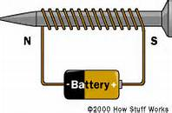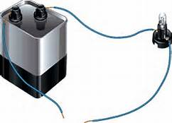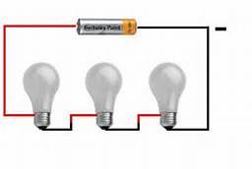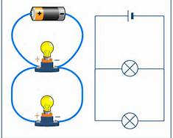

Ⓡ SCI.5.6C Demonstrate that light travels in a straight line until it strikes an object or travels through one medium to another and demonstrate that light can be reflected such as the use of mirrors or other shiny surfaces and refracted such as the appearance of an object when observed through water.

- reflection – light bounces off of smooth shiny surfaces (mirrors)
- refraction - light bends and objects appear bent or broken (fractured) – this is seen through lenses, prisms and water – (example- a pencil in water)
Transparent- see through Translucent – you can see through a little Opaque - solid

